**Group Project Proposal 3– Due 04/19/2025 @ 11:59 pm**

**Group Project Proposal 3 – The web Team must approve this!!**

**Each Member must upload a copy to the designated Dropbox in i-college**

**Group Members:**

[Student Name 1] **Phi Ly**

[Student Name 2] **Mebibora Akerjola**

[Student Name 3] if required.

In this assignment, you will submit a proposal for your group project. This proposal must include:

* Proposed Group Members
* Project summary
* Proposed the wireframe - visual representation of the detailed outline of the user interface (UI) and layout of an app.
  + Layouts - Number and name of unique screens in Project
  + Functionality - Proposed Use case from transitioning from screen to screen.
  + User Experience - Proposed Use cases for each Screen
  + Iterative design – Test cases and approach to refine the improvements.
* Proposed APIs you will integrate into your app. (if applicable)

**Project Summary: (Statement of topics and additional features that you will use)**

* Conway's Game of Life is a cellular automaton that simulates complex patterns from simple rules, offering an engaging way to explore emergent behavior. Our PHP-based web application will provide an interactive platform for users to experiment with the simulation
  + some of the features includes a 20x20 game grid with real time simulation
  + user authentication and session management
  + pattern library
  + user statistics

**Proposed Wireframe:**

* 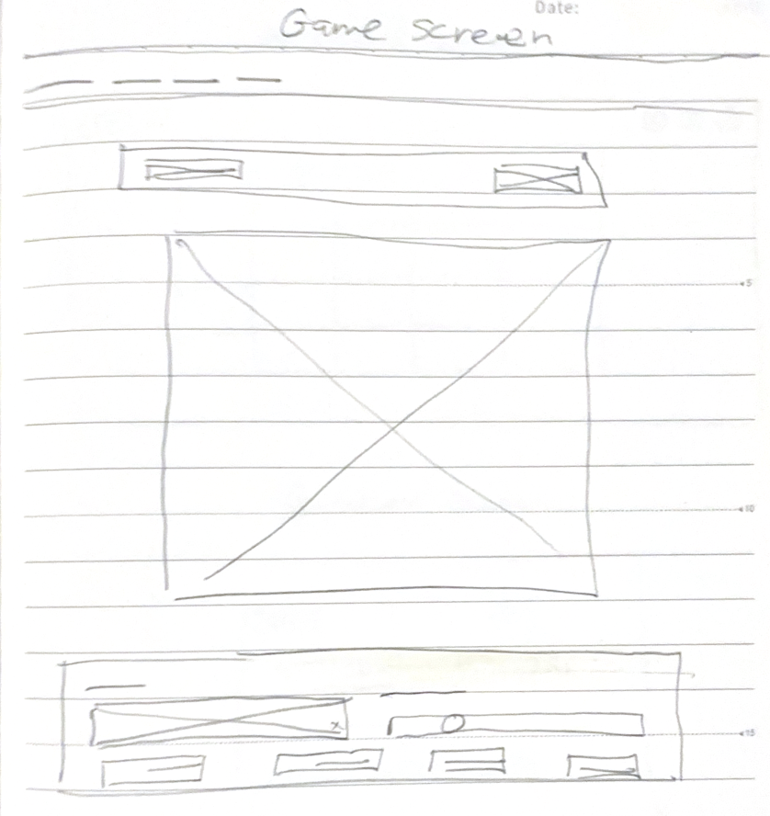
* 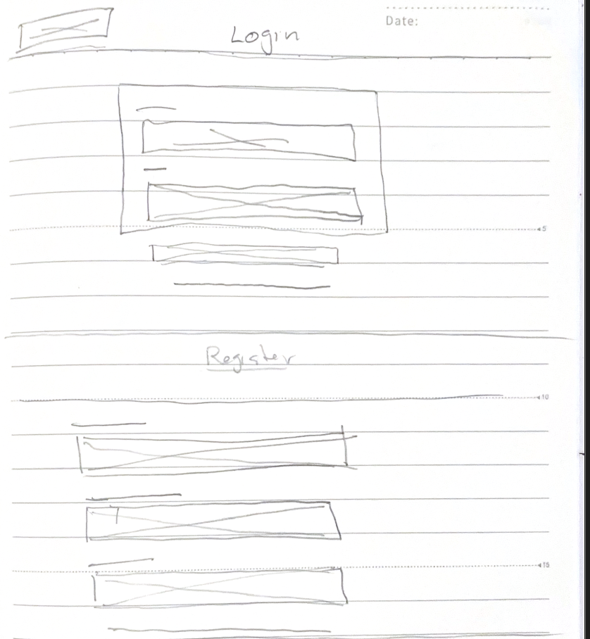

**Homepage details (intro):**

* Login page with register link at the bottom
* Game grid: 20x20 cell grid, clickable to toggle cells alive or dead
* Control panel: buttons for start/stop, step, reset, speed slider, pattern dropdown
* pattern selection

**Layouts:**

**Each Page Details:** (Explain the detailed information about the topic)

* **Login Screen**
  + **Inputs**: Username, Password.
  + **Button**: Login.
  + **Link**: To Registration page.
  + **Error Display**: Shows invalid login messages.
* **Registration Screen**
  + **Inputs**: Username, Email, Password, Password Confirmation.
  + **Button**: Register.
  + **Link**: To Login page.
  + **Error Display**: Shows validation errors (e.g., username taken).
* **User Dashboard**
  + **Welcome Message**: Personalized greeting (e.g., “Welcome, [Username]!”).
  + **Game Statistics**: Total games played, average generations.
  + **Recent Sessions**: List of recent game timestamps.
  + **Saved Patterns**: Table of user-created patterns with Load/Delete options.
  + **Achievements**: Progress bars for milestones (e.g., “Create 10 Patterns”)

**Functionality: Users register, through forms, control buttons, resetting grids, pattern systems**

**Transition implementation details:**

* **Screen transitions**
  + Navigation between screens relies on PHP redirects triggered by form submissions or button clicks.
* **Visual transition:** 
  + CSS provides smooth visual feedback for user interactions. Grid cells change appearance when toggled between alive and dead states with gradual color shifts

**Transformations implementation details:**

* **Grid state updates:**
* Each form submission from the game screen processes the current 20x20 grid to compute the next generation based on Game of Life rules.
* **Pattern loading**
  + Preset patterns, like Blinker or Gosper Glider Gun, are stored in the system and applied to the grid when selected from a dropdown menu via a form submission.

**Animations implementation details:**

* Grid cell animations
  + Users toggle cells between alive and dead state, the cells transition smoothly to another color.
* button animation
  + control buttons shift colors on hover

**User Experience:**

* game screen
  + click cells to toggle alive/dead
  + start/stop, step and reset buttons for simulation control
  + real time update
  + pattern dropdown
  + speed slider adjusts pace
* Dashboard
  + visual charts for game stats
  + session history with clickable links to reload games
  + pattern library with preview thumbnails

**Test Cases:**

Conduct usability testing with a focus group to gather feedback on navigation and user interaction.

Test the website's responsiveness on different devices and screen sizes.

* **Tests for login**
  + Proper result when user enters incorrect username or password
  + Proper result when user does not enter a username or password
  + Proper result when user enters correct username and password

* **Tests for Registration**
  + Proper result when user leaves any input blank before clicking register
  + Proper result when user enters invalid email
  + Proper result when password and password confirmation do not match
* **Tests for Dashboard**
  + Proper display of statistics and recent sessions when only 1 game has been played
  + Proper display of statistics and recent sessions when 0 games have been played
  + Proper display of statistics and recent sessions when multiple games have been played
  + Saved patterns are kept between logins
  + Deleted patterns do not reappear between logins
* **Tests for Game screen**
  + Proper result when clicking dead cell
  + Proper result when clicking live cell
  + Start button functions when simulation has paused
  + Stop button functions when simulation is running
  + Step button functions when simulation has paused
  + Reset button functions when simulation has any live cell
  + Proper pattern is displayed when selected
  + Proper result when adjusting the slider for game speed

**Approach to Refine Improvements:**

Incorporate user feedback to optimize the user interface and streamline the user experience.

Iterate on design elements based on usability testing results to ensure intuitive navigation and clear information presentation.

Explain - Proposed APIs if any:

**Statement:**

We, the undersigned members of the group, acknowledge that we understand the conditions outlined in this proposal. We are committed to actively participating in the implementation of the group project from start to finish. We understand that individual grades may vary based on our contributions and performance, and we agree to present an important phase of the work collectively.

Signed proposal:

Name: FN________**PHI** ____ ____________ LN _________**LY**___ ____________ [ ]

Name: FN________**MEBIBORA**____ ____________ LN _______**AKEREJOLA**_____ ____________ [ ]

Name: FN____________ ____________ LN ____________ ____________ [ ]

***This proposal outlines our plan to develop an interactive website that leverages CSS to create captivating user interfaces. We believe that this project aligns with the objectives of the web development class and offers an opportunity to explore CSS transformations, transitions, and animations in a practical setting. We are excited about the potential of this project and look forward to bringing our ideas to life.***